Flow chart: Extracellular signaling molecule -> receptor protein -> G-protein uses GTP/GDP/phosphate -> Kinase uses ATP/ADP/ phosphate -> transcription regulator binds to DNA and recruits RNA polymerase

- Extracellular signaling molecule (Technical name = EGF for epidermal growth factor): protein, free floating in liquid, does not change shape, binds to receptor protein
- receptor protein (Technical name = receptor tyrosine kinase, EGFR): protein, floats in membrane, one side binds extracellular signaling molecule, the other side binds an intracellular protein. Exists as two proteins which then come together upon binding the signaling molecule. Upon dimer formation (the two proteins coming together), it will autoselfphosphorylate. That is, it will add phosphates to itself. Upon phosphorylation, it will bind to the intracellular protein. Technically Grb2 (see the diagram below), for the first stages of the program, it is OK for it to bind to the G-Protein.
- G-protein (Technical name = RAS): the G-protein is so named because it binds GTP/GDP. In the OFF state, it is bound to GDP. Upon binding to a protein that activates it (SOS in the diagram below, but it is OK if it is the phosphorylated receptor protein for the first rendition), it will swap out a GDP for a GTP. It is then active and will activate a kinase.
- GTP/GDP/ phosphate: GTP is a nucleotide, not a protein. It has 3 phosphates on it. GDP is the same nucleotide with two phosphates instead of three. When GTP is converted (hydrolyzed) into GDP, the nucleotide stays the same, just the phosphate is lost. If a protein is bound to GDP, it cannot add the phosphate back. Instead it has to “spit out” the GDP and grab hold of a different GTP molecule. If you want to think about it as GTP being the pistachio nut, and you eat the nut (phosphate) and throw away the shell (GDP), this is a decent analogy.
- Kinase: Kinases add phosphates to things. The phosphates come from ATP. The situation is like the one above with GTP. A kinase takes a phosphate from ATP and then adds that phosphate to a protein (in this case, the transcription regulator). You are left with ADP, the “waste”. (In the diagram below, there are three kinases in a row.)
- ATP/ADP/ phosphate: ATP, like GTP, is a nucleotide. It acts basically the same as GTP. The difference is the way that they interact with proteins.
- transcription regulator: After being phosphorylated by the kinase, the transcription regulator will affect transcription, or the production of an mRNA transcript from DNA. In our case, it will bind to the DNA and increase transcription. It will increase transcription by recruiting, or allowing to bind, an RNA polymerase.
- DNA: The classic double helix. This guy just sits in the nucleus until the transcription regulator and the RNA polymerase bind to it.
- RNA polymerase: the RNA polymerase reads the DNA and makes a copy of the DNA out of RNA. It will bind to the DNA after the transcription regulator does.

The Incredible Machine: https://youtu.be/dl1LvFDgCio
The MAPK Signaling Pathway
https://youtu.be/oDjDUUhGVsI
https://youtu.be/JTY6_LRtUEE
https://youtu.be/hUC69VDkxjs

I found a couple of simulations with the same general idea of what I am visualizing:
http://phet.colorado.edu/en/simulation/gene-expression-basics
http://phet.colorado.edu/en/simulation/gene-machine-lac-operon

A few more:

https://www.youtube.com/watch?v=pSw5NLao7IQ (up to 1:10)

https://www.youtube.com/watch?v=oDjDUUhGVsI

https://www.youtube.com/watch?v=JTY6_LRtUEE

https://www.youtube.com/watch?v=npnLnzsWYFg

https://www.youtube.com/watch?v=Ia6OjvBazGE

https://www.youtube.com/watch?v=kiHAdan2AOY

https://www.youtube.com/watch?v=_Zq5qrVbN2A

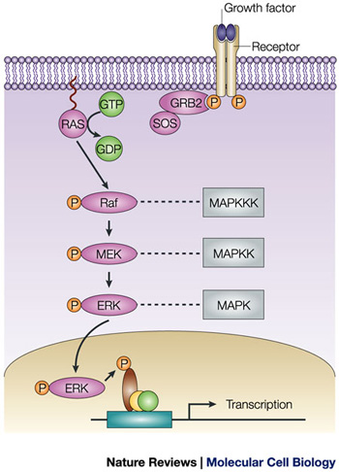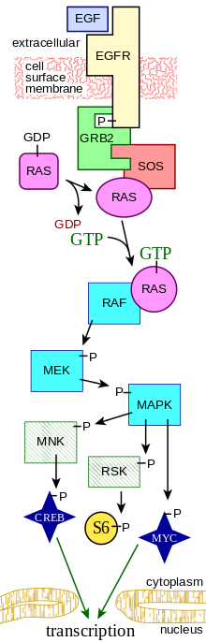

Check out the powerpoint for more information!

